About Arabic Language

Arabic is the official language of 24 countries throughout the Middle East and North Africa and it is the fifth most commonly spoken language in the world (see map below). There are more than 400 million Arabic speakers (native and non-native) around the globe. It is one of the six official languages of the United Nations.
Syria
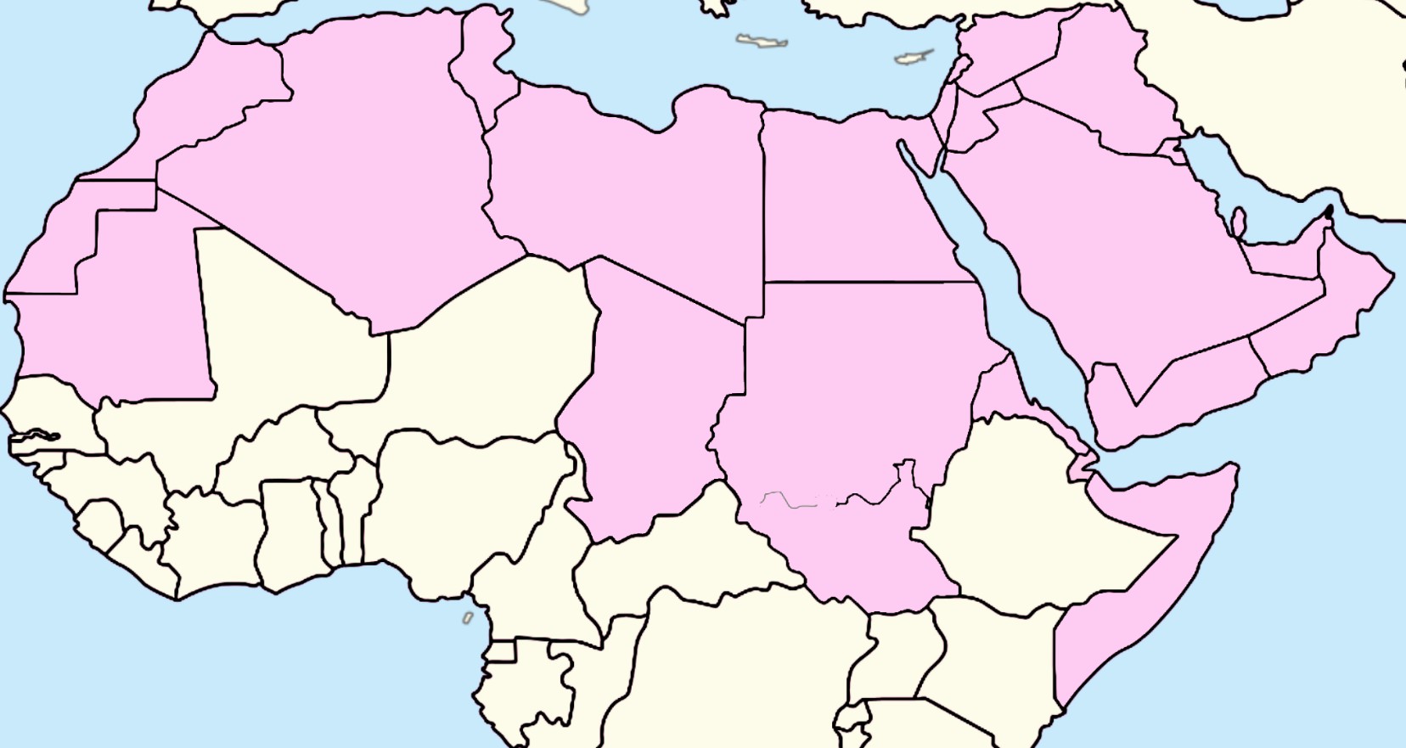
Western Sahara
Yemen
U.A.E.
Eritrea
Chad

Somalia
Mauritania
Algeria
Kuwait
Saudi Arabia
Jordan
Bahrain
Oman
Djibouti
Qatar
Palestine
Lebanon
Iraq
Sudan
Egypt
Libya
Tunisia
Morocco

Origin

Arabic is a Semitic language. Semitic languages, which are part of the larger Afro-Asiatic language family, emerged across the Middle East and North Africa over 4,000 years ago. Semitic languages include modern Arabic, Hebrew, Aramaic, and Ethiopic, as well as historic languages like Phoenician, Akkadian, and Syriac. All Semitic languages are written from right to left.

Forms of Arabic Language

The Arabic language has two forms: written and spoken. Written Arabic, known as Modern Standard Arabic (MSA) or Fus-ha (الفصحى) i.e. "eloquent" Arabic, is used in religious texts, writing, formal speeches, poetry, and newspapers. Colloquial spoken Arabic, known as Aamiya (عامية) is used conversationally. Various dialects of Aamiya are spoken across the Middle East and North Africa. Some of the more common forms of Aamiya are Levantine (from Greater Syria, i.e., Syria/Lebanon/Jordan/Palestine), Egyptian, Gulf, Moroccan, and Iraqi. Popular culture, including movies, music, and television all use Aamiya.

Akin to other Semitic languages, Arabic is written from right to left. Beyond its directional difference, Arabic and the Arabic alphabet have other key attributes that differentiate it from Indo-European languages (i.e., Romance languages like French, Italian or Spanish or Germanic languages like English, Dutch, or German). One of the most notable differences is in phonemes (i.e., sounds in the language). For example, certain phonemes in English simply do not exist in the Arabic alphabet, such as "p" or "g." As well, Arabic has a number of guttural sounds, which do not exist in English. The Arabic letters with a guttural pronunciation are 'ayn (ع), ghayn (غ), ha (ح), kha (خ), and alif hamza (أ). Some of these guttural letters are used to translate letters that do not exist in Arabic. For Example, the "g" in English would translate to "ghayn" in the Arabic alphabet.

Calligraphy

Calligraphy is the artistic practice of handwriting. While calligraphy exists in multiple languages around the world, Arabic calligraphy is a distinct art form. The fluid nature of Arabic letters lends itself towards creative expression. In addition, Arabic calligraphy frequently has a religious connotation. Arabic, the language of the Qur'an, is understood as a perfect language. The inherent perfection of the Qur'an in turn is expressed in Arabic calligraphy that beautifies the chapters (suras) of the Qur'an. Arabic is a poetic language, which can ingeniously be transformed into a stunning piece of artwork. As a linguistically rich language, looking at calligraphy derived from Arabic poetry is aesthetically beautiful on multiple levels.

Arabic calligraphy is not limited to the Middle East and North Africa. Over time, as Islam has spread through different cultures and regions, including southern Spain, Africa, and Southeast Asia, different regional characteristics have developed in Arabic calligraphy. Arabic calligraphy is an art form like no other where artists can mirror their identity and their respective cultural background in their work. Arabic calligraphy can act as a mirror for the artist as it can portray their own cultural background and identity within the artwork. According to Omani artist Saleh al Shukairi, "Arabic calligraphy is all about how you use your pen, and make the strokes." Calligraphy is believed to be the most spiritually fulfilling type of art for Omanis, as Arabic calligraphic artwork combine Islamic values and aesthetic beauty within each piece.

Conclusion

Arabic, in both its spoken and written form, is a beautiful language. While learning to read and write Arabic is not as difficult as one may presume, a passionate interest for learning the language will make one's journey through it a lot easier. The activities in this module will be your first steps in learning one of the world's richest languages.

Bibliography

Alhajri, Dr. Salman. "Contemporary Arabic Calligraphy Artworks." A'Design Award & Competition. February 19, 2014. Accessed August 05, 2019. https://competition.adesignaward.com/design.php?ID=32747.

Borges, Jane. "Unravelling Ruqa'a with Oman's Famous Calligrapher." Muscat Daily News. January 21, 2014. Accessed August 05, 2019. https://muscatdaily.com/Archive/Features/Unravelling-Ruqa-a-with-Oman-s-famous-calligrapher-2vev.

Jon. "Learn Arabic: It Could Be the Most Wonderful Language in the World." Superprof. May 3, 2018. Accessed August 5, 2019. https://www.superprof.com.au/blog/why-arabic-is-the-loveliest-language-of-all/.

Sayed, Faraan. "A Few Surprising Facts about the Arabic Language." A Few Surprising Facts about the Arabic Language | British Council. December 18, 2015. Accessed August 5, 2019. https://www.britishcouncil.org/voices-magazine/surprising-facts-about-arabic-language.

Testen, David. "Semitic Languages." Encyclopædia Britannica. July 20, 1998. Accessed August 05, 2019. https://www.britannica.com/topic/Semitic-languages.

Activity 1: Can You Locate All 24 Arabic Speaking Countries?
Background: This activity should be the first activity in this module. In this activity, students will learn to locate the countries where Arabic is an official language. Students will locate all 24 Arabic-speaking countries on the map. Make sure that students understand the following before beginning the activity:
- Arabic is the/one of the official languages of 24 countries throughout the Middle East and North Africa
- Arabic is the fifth most commonly spoken language in the world.
- There are more than 400 million Arabic speakers (native and non-native) around the globe.
- It is one of the six official languages of the United Nations.

Instructions:
- During the lesson preceding this activity, show students the map of the 24 Arabic speaking countries. After the map has been shown and discussed briefly, highlight the different regions that Arabic is an official language (North and sub-Saharan Africa, Middle East). How are these areas similar? Different?
- Print out copies of the blank map of the Arabic speaking countries enough for each student in the class. The blank map is provided on the next page.
- Instruct students to fill in as many countries as they can in the pink areas on the map, with a partner or with their table group. Give students a time limit of 10-15 minutes for this part.
- After the time is up, ask the class approximately how many Arabic speaking countries they were able to confidently locate on the map.
- Finally, show students the answer key on the overhead projector and ask them to self-check their answers.

Activity 2: Write & Decorate Your Name in Arabic
Background: This activity should be the second activity in this module. In this activity, students will be able to create artwork with their name in Arabic. Make sure students understand the following before beginning the activity:
- Arabic is written from right to left.
- Arabic and the Arabic alphabet have different alphabetic sounds from Indo-European languages (i.e., Romance languages like French, Italian or Spanish or Germanic languages like English, Dutch or German).
  - So for example, if a student’s name is “Peter”, they will have to use “baa” instead of “p” to write the first letter in Arabic, because “p” does not exist in the Arabic alphabet.
  - Students should have a vague idea of the Arabic alphabet before starting this activity.
Materials:
- Templates with an arabesque border. The arabesque border template is provided on the SQCC website.
- Thick cardstock paper
- Watercolor paints
  - Note: If paints and paint brushes cannot be provided, markers and crayons will do.
- 2-3 cups of water per table for rinsing paint brushes.
- Stencils of the names of all the students in the class in Arabic (contact SQCC)
- Pencils for each student
Instructions:
- Contact SQCC to have them prepare your students’ names in Arabic.
- Distribute the Arabic alphabet sheet to the class. Go through all of the letters together as a class.
- Print out the templates with an arabesque border from the SQCC website onto the thick cardstock paper. Make sure there are enough templates for every student in the class.
  - Note: Different template designs are available on the SQCC website. Teachers are advised to print out multiple patterns so students may select their preferred border.
- Set up enough paintbrushes at a table for each student as well as 2-3 watercolor palettes for students to share at a table.
- Distribute the water at each table for the paintbrushes.
- After all the materials have been distributed, ask students to stencil their name on to the cardstock paper in pencil.
- After the names have been stenciled in Arabic, students may begin painting/coloring them in.

Arabic Alphabet
Alone | End |  | Middle | Beginning | Name of Letter in Arabic | Letter in English | Letter  In Arabic
 | ـا |  | ــا | ا | Alif | a | أ
ب | ــب |  | ــبــ | بـ | Bā | b | ب
ة | ـــة | ـــت | ــتــ | تـ | Tā | t | ت
ث | ـــث |  | ـــثــ | ثـ | Thā | th | ث
ج | ــج |  | ـــجـــ | جـ | Jīm | j | ج
ح | ـــح |  | ـــحـــ | حـ | Hā | ḥ | ح
خ | ـــخ |  | ـــخـــ | خـ | Khā | kh | خ
د | ـــد |  | ـــد | د | Dāl | d | د
ذ | ـــذ |  | ـــذ | ذ | Dhāl | dh | ذ
ر | ـــر |  | ـــر | ر | Rā | r | ر
ز | ـــز |  | ـــز | ز | Zā | z | ز
س | ـــس |  | ـــســـ | سـ | Sīn | S  Ce - Ci | س
ش | ـــش |  | ـــشـــ | شـ | Shīn | Sh  Ch - Cia - Su - tia - tio | ش
ص | ـــص |  | ـــصـــ | صـ | Ṣād | ṣ | ص
ض | ـــض |  | ـــضـــ | ضـ | Ḍād | ḍ | ض
طـ | ـــط |  | ـــطـــ | طـ | Ṭā | ṭ | ط
ظــ | ـــظ |  | ـــظـــ | ظـ | Ẓā | ẓ | ظ
ع | ــع |  | ـــعـــ | عــ | ‘Ain | ‘  E - O | ع
غ | ـــغ |  | ـــغـــ | غـــ | Ghain | Gh | غ
ف | ـــف |  | ـــفـــ | فــ | Fā | F - ph - augh | ف
ق | ـــق |  | ـــقـــ | قــ | QāF | q | ق
ك | ـــك |  | ـــكـــ | كـــ | Kāf | k | ك
ل | ـــل |  | ـــلـــ | لـــ | Lām | l | ل
م | ـــم |  | ـــمـــ | مـــ | Mīm | m | م
ن | ـــن |  | ـــنـــ | نـــ | Nȕn | n | ن
ه | ـــه |  | ـــهـــ | هـــ | Hā | h | هـ
و | ـــو |  | ـــو | و | Wāw | w | و
ي | ـــي |  | ـــيـــ | يـــ | Yā | Y/i/e | ي

Activity 3: Make Your Own Piece of Calligraphy Artwork!
Background: This activity should be the third activity in this module. In this activity, students will be able to make their own piece of calligraphy artwork to keep and admire. Make sure students understand the following before beginning the activity:
- Arabic calligraphy is a form of artistic writing of the Arabic language.
- While calligraphy exists in multiple languages around the world, Arabic calligraphy is a distinct art form.
- The fluid nature of Arabic letters lends itself towards creative expression.
- Encourage students to express themselves in their pieces of Arabic calligraphy using different patterns, shapes, and colors.
Materials:
- Mini canvases for enough students in the class
  - Note: If mini canvases are unavailable, teachers may print out a template with an arabesque border on thick cardstock paper. The arabesque border template is provided on the SQCC website.
- Paint brushes
- Acrylic or watercolor paints (acrylic for canvas, watercolor for cardstock)
  - Note: If painting is not an option, markers and crayons will do. However, traditionally, calligraphy is painted.
- Enough plates for each student in the class to use the plate as a paint palette
- 2-3 cups of water per table, for rinsing paint brushes.
- Pencils for each student
- Stencils of Arabic phrases (provided on the SQCC website)

Instructions (if using paints):
- Print out several copies of the stencils of Arabic greetings for each table of students to share.
- Set up enough paintbrushes at a table for each student, as well as 2-3 paint palettes for students to share at a table.
  - If the teacher is able to provide canvases, distribute 2-3 colors of acrylic paints per table.
- Distribute the water at each table for the paintbrushes.
- After all the materials have been distributed, ask students to stencil their greeting on to the canvas or cardstock paper in pencil.
- After the phrases have been stenciled on to the canvas/cardstock, students may begin painting them in.
- When painting, instruct students to try to paint with as few strokes as possible. Encourage them to paint swiftly and smoothly just like professional calligraphers.
- After students are finished with their pieces, let dry and behold beautiful Arabic calligraphy artwork!
Instructions (if using markers and crayons with cardstock paper):
- Print out several copies of the stencils of Arabic greetings, enough for each table of students to share.
- Print out various designs of the designed templates from the SQCC website, onto thick cardstock paper, enough for each table of students to share.
- Provide crayons and markers at each table, enough for students to share.
- After all the materials have been distributed, ask students to stencil their greeting onto the canvas or cardstock paper in pencil.
After the phrases have been stenciled in Arabic, students may begin coloring.

Activity 4: Learn the Names of the Omani provinces in Arabic and Where They Are Located on a Map

Background: This activity should be the fourth activity in this module. In this activity, students will be able to write the names of the Omani provinces in Arabic and learn where they are located on a map of Oman. Make sure the students understand the following before beginning the activity:

- Arabic is written from right to left
- Leave enough space between words
- In Arabic short vowels are normally not written

Materials:

- Papers
- Pencils
- Erasers

Instructions:

- Print out the names of Omani provinces written in dotted font in English & Arabic provided on the next page. Print out enough copies for each student in the class.
- Go over the province names in English and Arabic. Practicing how to pronounce the names together as a class.
- Ask students to trace the Arabic words in dotted font.
- After learning the names of the Omani provinces, have students find the provinces in the word search.
- As the final part of the lesson, distribute the map of Oman. Have the students then match the province name with its numbered location.
Provinces of Oman
Arabic | Pronunciation | Province
الداخلية | Ad Da-khi-li-yah | Ad Dakhiliyah | 1
الظاهرة | Ad Dha-hi-rah | Ad Dhahirah | 2
شمال الباطنة | Al Bat-nah North | Al Batinah North | 3
جنوب الباطنة | Al Bat-nah South | Al Batinah South | 4
البريمـي | Al Bu-rai-mi | Al Buraimi | 5
الوسطى | Al Wus-ta | Al Wusta | 6
شمال الشرقية | Ash Shar-qi-yah North | Ash Sharqiyah North | 7
جنوب الشرقية | Ash Shar-qi-yah South | Ash Sharqiyah South | 8
ظفار | Dho-far | Dhofar | 9
مسقط | Mus-cat | Muscat | 10
مسندم | Mu-san-dam | Musandam | 11

